MANOA JUNIOR FIREFIGHTER PROGRAM
STATION 56

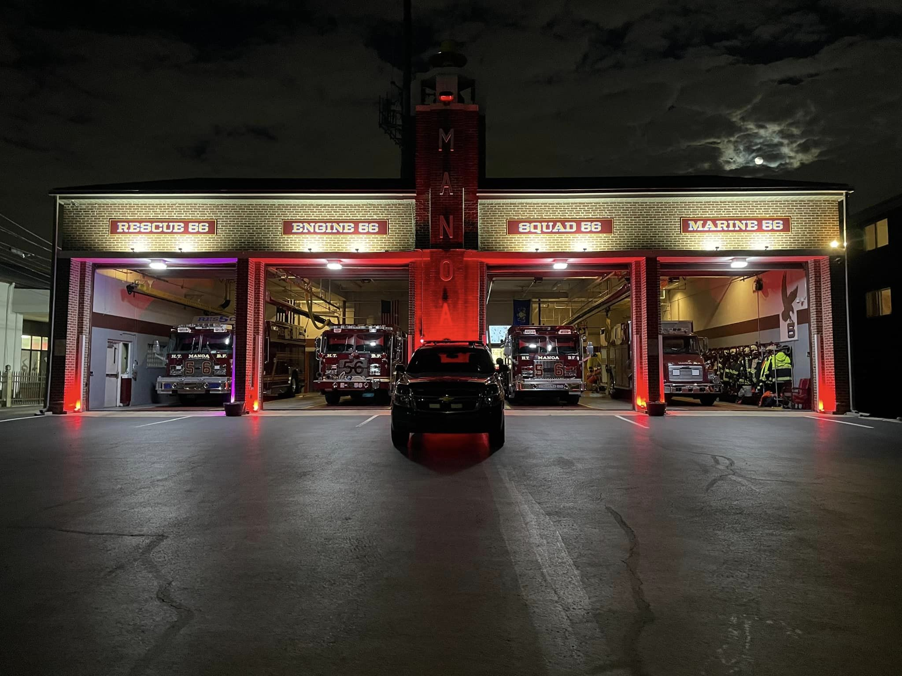

THE FOLLOWING PROGRAM WILL CONSIST OF ANY MEMBER 16 YEARS OF AGE OR OLDER:
STEPS TO BE TAKEN:
- APPLICATION FILLED OUT
- REFRENCES WERE CALLED
- WORKING PAPERS PRESENT
- PARENT MEETING W/JUNIOR MEMBER
- LAST REPORT CARD PRESENT
- TOWNSHIP PHYSICAL
- CHILD ABUSE CLEARENCE
- CRIMINAL BACKGROUND CHECK
- APPROVAL TO BECOME FULL MEMBER
- GIVEN FULL PPE
- ASSIGNED A SENIOR MEMBER TO SHADOW
- LEARN TRUCKS AN EQUIPMENT

The Manoa Fire Company has adopted these rules and regulations to govern our Junior Emergency Services Program. Our goal is prepare young people to be the safest and well-trained responders they can be and to provide the best opportunity for the future of our organization. These rules and regulations are to be strictly adhered to by all members of the Manoa Fire Company.
• Being accepted to Junior Membership is a privilege granted to those members between 16 and 18 years of age who wish to serve and protect the community.
• Prior to acceptance into the Department, he/she must obtain a work permit and shall have an application signed by a parent or legal guardian. All documents must then be on file.
• The juniors will be directly supervised by the regular fire department line officers, and a junior committee made up of two members of the regular fire department, assigned by the chief, to act as the “Liaison” and “Advisor/Coordinator”.
• Junior members shall obey the constitution, by-laws and all other company rules and regulations. Duties of Junior Members
• Junior Members should make every effort to attend training sessions, work/service details and responses when permitted by the Child Labor Law and Fire Department/Company guidelines.
• Junior Members shall follow the established chain of command and work with their advisor/coordinator.
• Junior Members will assist with cleaning apparatus, equipment and after events.
• Junior Members can attend fund raising activities, if available.
• Junior Members may attend meetings, but do not have any voting privileges.
• All juniors will sign in and out when entering and leaving the stations.

RULES SET FOURTH BY PA STATE FIRE COMMISSIONER TO BE FOLLOW BY MANOA FIRE COMPANY:
A. Minor - Any individual under 18 years of age.
B. Volunteer Emergency Service Organization - A volunteer fire company, volunteer ambulance organization, volunteer rescue organization, a volunteer forest firefighting organization or a volunteer organization of emergency service personnel who are expected to respond to medical emergencies or large-scale disasters.
C. Work Permit – a transferrable work permit allowing employment of a minor.
D. Time limitations and Age Restrictions of employment of minors:
1. No minor may be employed for more than five hours continuously without an interval of at least 30 minutes for a rest break. No period of less than 30 minutes shall be deemed to interrupt a continuous period of work.
a. Time spent at the volunteer organization socializing with other members is not counted as work hours.
b. Time attending meetings or “manning” the station should be considered work.
2. Time restrictions – a minor may not be employed for more than six consecutive days.
3. Minors who are seventeen (17) years of age and have graduated high school are still covered by the Child Labor Act except for time limits.

Hours of Employment– Ages 16 or older
1. The minor may not be employed before 6 a.m. or after 12 midnight, except that during a school vacation period a minor shall be permitted to be employed until 1 a.m. a. No night work.
2. The minor may not be employed for more than eight hours on a school day and no more than 10 hours on a day when there is no school.
3. The minor may not be employed for more than 28 hours per week during a regular school week.
4. The minor may not be employed for more than 48 hours during a week when school is not in session.
5. A minor enrolled in summer school is subject to items 1, 2 and 3 above.
Time Restrictions Exception:
- A minor may continue serving in answer to a fire call until excused by the individual acting as chief of the fire company if the minor:
a. Is 16 years of age or older.
b. Is a member of a volunteer of a volunteer fire company
c. Answers a fire call while lawfully employed.
Exception for Employment Outside of “Hours of Employment”:
a. Sixteen and seventeen year old junior members of an emergency service organization, who begin operations at an emergency incident during legal hours, are permitted to continue activities until excused by the fire chief or officer-in-charge. These juniors will not be considered in violation of the “hours of employment” section of the PA Child Labor Law. b. Example: A fire starts at 11 PM on a Saturday night during the school year. The fire department responds. Junior members are present on the fire scene operating under the supervision of an officer. The fire is not extinguished until 2 AM. The juniors are NOT in violation of the “hours of employment” section of the Child Labor Law. However, when the officer-in-charge releases them, they must go home. They may not respond to another alarm until the morning “hours of employment” start.

Minors serving in volunteer emergency service organizations.
- General Rule – An individual who is 16 years of age or older who is a member of a volunteer emergency service organization may participate in training and emergency service activities except as follow:
a minor may…
- NOT operate a truck, ambulance or other official fire vehicle.
- NOT Operate an aerial ladder, aerial platform or hydraulic jack.
- NOT use rubber electrical gloves, insulated wire gloves, insulated wire cutters, life nets or acetylene cutting units.
- NOT operate the pump of a fire vehicle while at the scene of a fire.
- NOT enter a burning structure under any circumstances including a training exercise.

2. General Rule – A minor many not engage in firefighting activities unless all of the following apply:
a. The minor is 16 years of age or older
b. The minor has successfully completed a course of training equal to the standards for basic firefighting established by the State Fire Commissioner. The Pennsylvania Entry Level Fire Training curriculum allows junior firefighters to take training and participate in “Exterior” fire suppression activities.
d. The minor is under the direct supervision and control of the fire chief, an experienced line officer. The member must be under the direct supervision and control of the fire chief or a trained experienced officer over 21 years of age. Direct supervision means that the officer must be within speaking and touching distance of the junior member.

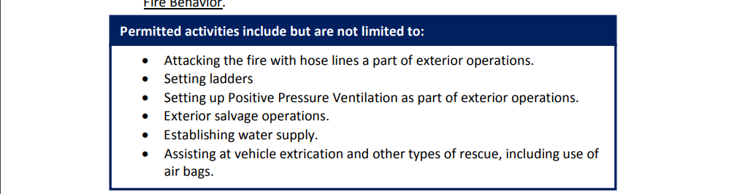
Prohibited Activities - L&I may prohibit other activities that it deems hazardous to the health of minors through regulation. (For additional information see Appendix C)
1. Section 4(b) of the newly-enacted Child Labor Act (CLA) (Act of October 24, 2012, P.L. 1209, no. 151, effective January 22, 2013) requires the Department of Labor and Industry (Department) to publish a list of hazardous or otherwise prohibited establishments or occupations for minors.
2. This list is derived from three sources: (1) occupations and establishments expressly prohibited for minors under Section 4(a) of the CLA, (2) any occupation or establishment designated as hazardous and otherwise prohibited for minors under the federal Fair Labor Standards Act (FLSA) and regulations under that act, and (3) additional prohibited or hazardous occupations for establishments set forth in the Department’s regulations. According to Section 29 of the CLA, the current regulations shall be those adopted under the former Child Labor Law until modified or deleted by the Department
. • Juniors are not permitted to pilot (operate) or operate any water rescue boat or vessel.
• Junior are not permitted to operate any aerial device mounted on a fire apparatus.
• Juniors are not permitted to operate elevators or participate in elevator rescues.
• Juniors are not permitted to perform rescue operations in tunnels, shafts, or trenches.
• Juniors are not allowed to participate in emergencies at firework plants, retailers, or in support of public safety for a public display.
• Juniors are not permitted to perform emergency operations in or around mines, strip mines, or quarries. The following are prohibited activities designated as hazardous for all junior emergency service personnel: Junior Emergency Services Compliance Manual - Revised November 2015 Pennsylvania State Fire Academy 10 of 43
• Juniors are not permitted to participate in the response to incidents involving paint products.
• Juniors are not permitted to participate in the response to incidents involving radioactive substances. • Juniors are not permitted to perform rooftop ventilation or any other work on any roofs.
• Juniors are not permitted to operate acetylene torches, cutting or crushing equipment, or respond to structural collapse incidents.
• Juniors are not permitted to operate circular saws, band saws, guillotine shears, chain saws, reciprocating saws, wood chippers, and abrasive cutting discs.

RESPONDING TO ALARMS
• Juniors shall not answer fire alarms until given approval by the Fire Chief.
• All juniors, if driving, must report to the station for all calls. If all of the apparatus has already responded when you arrive at the station, juniors are to stand-by at the station until either a senior member stops and gives them a ride to the scene, or wait until the department returns from the call to assist in clean-up duties.
• Junior members 16-17 may respond but are not permitted to use a blue courtesy light or hazard lights (four ways) while in route to the station for a call.
• All traffic laws shall be strictly obeyed. Permission to drive their personal vehicle directly to the scene of any alarm must be approved by the Fire Chief.
• Sixteen and Seventeen year old junior members will only be permitted to respond to fire calls after the successful completion of either the departments own orientation program or Fire School. A copy of the certificates from courses must be on file.
• Senior Members have priority for seating on a fire response. Juniors will be instructed by the officer or senior member in charge where they may ride on responding fire vehicles. If all positions are taken on the first responding unit, the junior must wait to respond on the second responding unit, if there is sufficient room to do so.
• Juniors shall don full protective bunker gear before boarding any piece of fire apparatus that is responding to a call unless otherwise instructed by a line officer.
• Junior Members must be seated and seat belted in an enclosed vehicle.
• Junior Members are not permitted to leave school to answer an alarm or attend a training session or detail without written permission.
• Junior Members will not start, drive/operate or move any fire apparatus.
On The Scene
• Junior Members must report and receive permission to leave the Fire Scene by the Officer in charge.
• Junior Members should report to the officer in charge in full protective gear and be assigned by the Officer in charge. Freelancing is prohibited.
• Junior Members may only operate equipment as directed by the officer in charge.
• Junior Members are not allowed to enter any burning structure.
• Junior firefighters responding to a mutual aid call into another department’s jurisdiction must get permission from an officer to board truck and shall stay with our apparatus until ordered by one of the line officers on the scene.
At no time is any junior member allowed to roam around a fire scene on his/her own. Junior members are to remain with the crew at all time.

GENERAL RULES&REGULATIONS:
• Supervision of Junior Members is defined by the Fire Company By-Laws. On the scene of an incident the officer in charge/designee is responsible for direct supervision. All juniors will be governed in accordance with the Child Labor Law, Bureau of Labor Law Compliance and Commonwealth of Pennsylvania.
• No use of profanity, horseplay, wrestling, physical sports or fighting shall be tolerated on or about the station.
• Junior members shall be respectful to all members and the public. Officers should be addressed by their titles. Juniors may attend Fire Department meetings, but shall not be permitted to make or second any motions, nor shall they be able to vote on any issues. With approval, they may attend all drills and fire schools scheduled.
• Probation for juniors shall be from the date of acceptance to (90 DAYS) as defined in the company by-laws. With a majority vote from the membership at a regular company meeting, they shall be a regular junior member and off probation.
• Time restrictions: Juniors age 16 and 17 years old on school nights: not to exceed 12:00 AM (Midnight) unless involved in a Company function. Non-school nights: not to exceed 1:00 am, Friday night into Saturday, Saturday night into Sunday, or Night proceeding into a school holiday.
• All Junior Members will maintain a good academic eligibility of “c”. Parents or legal guardians shall be required to notify the fire company if the overall average drops below an overall “C” average. Those who have their grade average drop below a “C” average or has an “F”, regardless of the overall average, shall be suspended from ALL fire department activities*. The junior shall remain on suspension from all activities until the next grading period. The report card shall be presented to the fire company. A copy shall be kept on file in the respective junior’s personnel file.
• A junior may be reinstated before the next grading period expires if he/she receives a note from the instructor or guidance counselor, in writing and signed, on school district letterhead, stating that the grade average has risen to a “C” average.
• The student member will submit their report card to the Advisor/committee within (15 days) after being issued. If the report card is not submitted, the Junior Member will not be permitted to participate in any company activities.
• All juniors shall be under suspension if enrolled in summer school program for failure to pass subjects during the normal school year for the duration of the summer program
. • Any equipment issued to a junior shall be kept in good repair and maintained to Fire Department guidelines. Special equipment or sizes shall not be purchased. He/she may use equipment that was personally purchased as long as a Chief Officer approves such equipment use.
• Juniors shall not be permitted to take any Fire Company issued firefighting equipment to school.
• Junior Members will attend training as identified by the department/company. No junior may enroll in any courses offered through the fire Department without the Chief or Training officer’s approval.
• Junior firefighters are prohibited from using any tobacco products on Fire Company properties, fire ground operations, or any fire related public service activities. Juniors who are under the influence of alcohol, or has the smell of alcohol or any alcoholic beverages or controlled substances in his/her possession and are on Fire Company property, fire ground, or any function held by the Fire Company may be immediately expelled. Any junior who is involved in illegal activity outside of the Fire Company shall be subject to expulsion from the Department.
• Juniors shall not be permitted to drive Fire Company vehicles at any time.
• Junior Members will be on their best behavior and be respectful while representing this department/company.
. • Junior members are not permitted to sleep in the bunkroom, except under special circumstances, and then only with the expressed permission of the fire chief and/or president.
• Junior Members must comply with applicable Pennsylvania Child Labor Law provisions. If found non-compliant, the member is subject to reprimand by the department/company.
• Juniors are covered by the Fire Company insurance policy at all functions.
• Where junior firefighter rules do not prevail, Fire Department rules will prevail. This version of the Junior Rules and Regulations shall immediately supersede any and all versions prior.
• Failure by any member of the junior fire department to abide by these rules listed above will result in suspension and possible expulsion from the junior fire department.
.JUNIORS WILL NOT POST ANY KIND OF SOCIAL MEDIA POST VIA FACEBOOK,INSTAGRAM,SNAPCHAT OR ANY OTHER PLATFORMS OF CALLS ON SCENE, GOING TO CALLS OR RETURNING FROM CALLS TO PROTECT PRIVACY ACTS
• All rules and regulations governing juniors are subject to change at any time.

Act 155
Act 155 was signed into law Nov. 3, 2022, and went into effect Jan. 4, 2023.
It allows the state training system to provide the same interior firefighting training to 17-year-old junior firefighters that was previously only allowed at career and technology center schools.
Act 155 applies only to junior firefighters who are at least 17-years-old on the first day of class, and only applies to finishing Entry Level Interior Firefighter Training, or ELIF. The exception is not applicable to any other fire training.
We are exploring a reduction in the minimum age to test for Firefighter 1 for 17-year-old junior firefighters who have completed ELIF, but no final action has been taken.

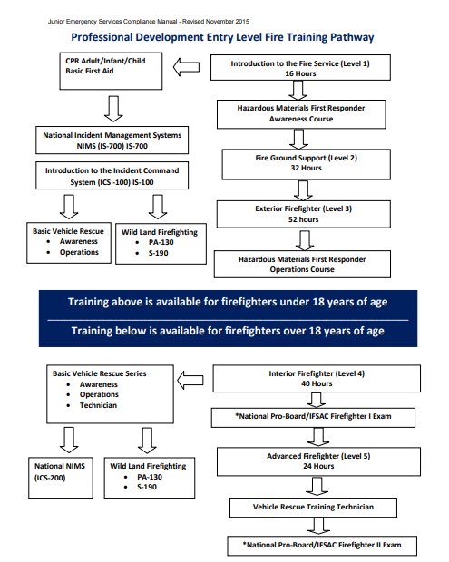
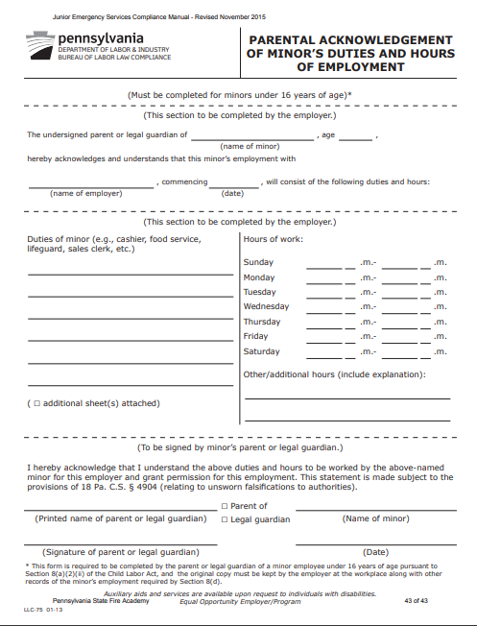

MAM

MANOA FIRE COMPANY RULES AND REGULATIONS

I____________________________have received a copy of the rules and regulations set forth by Manoa Fire
Company. I have read and understand the rules and regulations set forth by Maona Fire Company regarding
The junior member program. By my signature, I attest that I will follow these rules and regulations and understand
The consequences if I do not abide by them.

_____________________________ _____________________
(junior member signature) (Date)

_____________________________ _____________________
(Parent or legal guardian signature) (Date)

________________________________ _____________________
(officer signature) (Date)

II

